**DEPARTMENT OF COMPUTER SCIENCE AND APPLICATIONS**

**PANJAB UNIVERSITY**



**Java Practical Assignment – File Handling**

**Submitted To : Submitted By :**

Asst. Professor Jasleen Kaur Rishika Gautam (88)

MCA II (Evening)

**1. Create a Java program that Reads a text file (input.txt) using FileInputStream and**

**Scanner. It should count the frequency of each word (ignore case and punctuation).**

**Outputs the word frequencies to another file (word_count.txt) using FileOutputStream.**

import java.io.FileInputStream;

import java.io.FileWriter;

import java.io.IOException;

import java.util.HashMap;

import java.util.Scanner;

public class p1 {

    public static void main(String[] args) throws IOException {

        Scanner sc = new Scanner(System.in);

        String text = sc.nextLine();

        try (FileWriter writer = new FileWriter("input.txt")) {

            writer.write(text);

        }catch(IOException e){

            System.out.println("Error"+e.getMessage());

        }

        FileInputStream fileS = new FileInputStream("input.txt");

        Scanner fileSc = new Scanner(fileS);

        HashMap<String, Integer> hash = new HashMap<>();

        while (fileSc.hasNext()) {

            String word = fileSc.next().replaceAll("[^a-zA-z]","").toLowerCase();

            if(!word.isEmpty()){

                hash.put(word, hash.getOrDefault(word,0)+1);

            }

        }

        System.out.println(hash);

        FileWriter output = new FileWriter("output.txt");

        for(String word : hash.keySet()){

            output.write(word+" : "+ hash.get(word)+"\n");

        }

        output.close();

        fileS.close();

        sc.close();

        fileSc.close();

    }

}

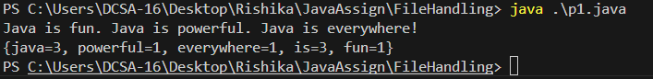

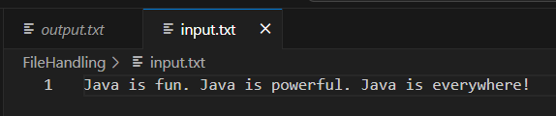

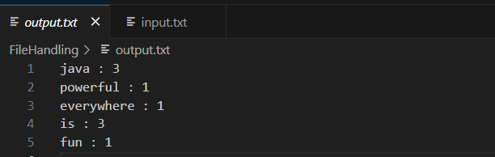

**2. Write a Java program that:**

**• Reads the contents of a file (input2.txt) using FileInputStream and Scanner.**

**• Replaces every vowel in each word with * and every consonant with #.**

**• Writes the modified content to a new file (masked_output.txt) using**

**FileOutputStream.**

import java.io.*;

import java.util.Scanner;

public class p2 {

    public static void main(String[] args) {

        StringBuilder str = new StringBuilder();

        try (

            FileInputStream fileS = new FileInputStream("input2.txt");

            Scanner sc = new Scanner(fileS);

         ){

            while(sc.hasNextLine()){

                String line = sc.nextLine();

                line = line.toLowerCase();

                System.out.println(line);

                for (int i = 0; i < line.length(); i++) {

                    char ch = line.charAt(i);

                    if (Character.isLetter(ch)) {

                        if (ch == 'a' || ch == 'e' || ch == 'i' || ch == 'o' || ch == 'u') {

                            str.append("*");

                        } else {

                            str.append("#");

                        }

                    } else {

                        str.append(ch);

                    }

                }

                str.append("\n");

            }

         } catch (IOException e) {

            e.printStackTrace();

        }

        System.out.println(str);

        try (FileOutputStream fos = new FileOutputStream("masked_output.txt")) {

            fos.write(str.toString().getBytes());

        } catch (IOException e) {

            System.out.println("Error : " + e.getMessage());

        }

    }

}

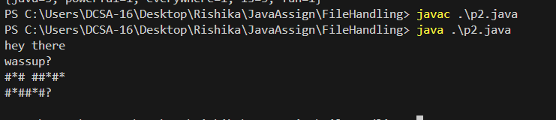

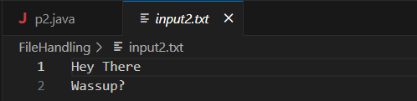

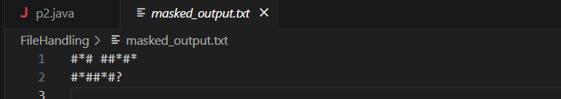

**3. Create a Java program that:**

**• Reads all lines from a file (lines.txt) using FileInputStream and Scanner.**

**• Sorts the lines in ascending alphabetical order.**

**• Reverses each line individually (character-wise).**

**• Writes the sorted and reversed lines to a new file (reversed_sorted_lines.txt) using**

**FileOutputStream.**

import java.io.*;

import java.util.*;

public class p3 {

    public static void main(String[] args) {

        ArrayList<String> lines = new ArrayList<>();

        try (

            FileInputStream fis = new FileInputStream("lines.txt");

            Scanner scanner = new Scanner(fis)

        ){

            while (scanner.hasNextLine()) {

                lines.add(scanner.nextLine());

            }

        } catch (IOException e) {

            System.out.println("Error: " + e.getMessage());

        }

        Collections.sort(lines);

        System.out.println("sorted Lines: \n"+lines);

        try (

            FileOutputStream fos = new FileOutputStream("reversed_sorted_lines.txt");

            PrintWriter writer = new PrintWriter(fos)

        ){

            System.out.println("Rotated Line:");

            for (String line : lines) {

                String reversed = new StringBuilder(line).reverse().toString();

                System.out.println(reversed);

                writer.println(reversed);

            }

        } catch (IOException e) {

            System.out.println("Error : " + e.getMessage());

        }

    }

}

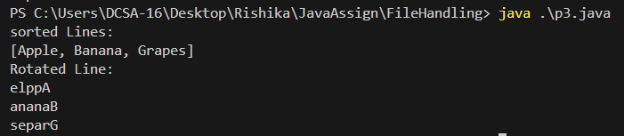

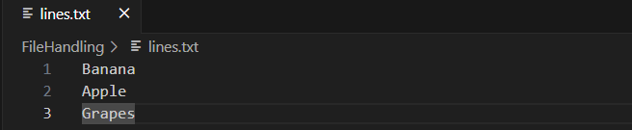

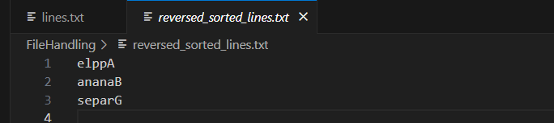

**4. Write a Java program that:**

**• Reads a paragraph from a text file (paragraph.txt) using FileInputStream and**

**Scanner.**

**• Replaces every second occurrence of each word with the string "REDACTED".**

**• Writes the modified paragraph to a new file (redacted_output.txt) using**

**FileOutputStream.**

import java.io.FileInputStream;

import java.io.FileWriter;

import java.io.IOException;

import java.util.HashMap;

import java.util.Scanner;

public class p4 {

    public static void main(String[] args) {

        HashMap<String, Integer> hash = new HashMap<>();

        try (

                FileInputStream fileS = new FileInputStream("paragraph.txt");

                Scanner FileSc = new Scanner(fileS);

                FileWriter output = new FileWriter("redacted_output");

        ) {

            while (FileSc.hasNext()) {

                String word = FileSc.next();

                int count = hash.getOrDefault(word, 0);

                if (count >= 1) {

                    System.out.print("redacted ");

                    output.write("redacted ");

                } else {

                    System.out.print(word + " ");

                    output.write(word + " ");

                }

                hash.put(word, count + 1);

            }

        } catch (IOException e) {

            System.out.println("Error: " + e.getMessage());

        }

    }

}



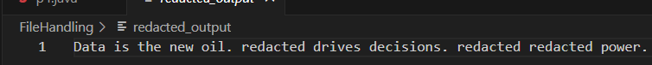

**5. Write a Java program that analyzes a server log file (server_log.txt) containing multiple**

**log entries. Each entry includes a timestamp, a log level, and a message. Your task is to:**

**a. Parse the log file using FileInputStream and Scanner.**

**b. Extract and categorize log entries by severity (INFO, WARNING, ERROR).**

**c. Count the number of occurrences of each log level.**

**d. Find and redact sensitive data (like email addresses and IP addresses).**

**e. Generate two output files:**

**• log_summary.txt — A summary of log counts per severity.**

**• sanitized_log.txt — The modified log with sensitive data redacted.**

import java.io.*;

import java.util.*;

import java.util.regex.*;

public class p5 {

    public static void main(String[] args) throws IOException {

        FileInputStream fis = new FileInputStream("server_log.txt");

        Scanner scanner = new Scanner(fis);

        PrintWriter summaryWriter = new PrintWriter("log_summary.txt");

        PrintWriter sanitizedWriter = new PrintWriter("sanitized_log.txt");

        Map<String, Integer> logCounts = new HashMap<>();

        Pattern emailPattern = Pattern.compile("\\b[\\w.-]+@[\\w.-]+\\b");

        Pattern ipPattern = Pattern.compile("\\b(?:\\d{1,3}\\.){3}\\d{1,3}\\b");

        while (scanner.hasNextLine()) {

            String line = scanner.nextLine();

            if (line.contains("INFO")) logCounts.merge("INFO", 1, Integer::sum);

            else if (line.contains("WARNING")) logCounts.merge("WARNING", 1, Integer::sum);

            else if (line.contains("ERROR")) logCounts.merge("ERROR", 1, Integer::sum);

            line = emailPattern.matcher(line).replaceAll("[REDACTED_EMAIL]");

            line = ipPattern.matcher(line).replaceAll("[REDACTED_IP]");

            sanitizedWriter.println(line);

        }

        summaryWriter.println("Log Level Summary:");

        for (String level : List.of("INFO", "WARNING", "ERROR")) {

            summaryWriter.println(level + ": " + logCounts.getOrDefault(level, 0));

        }

        scanner.close();

        summaryWriter.close();

        sanitizedWriter.close();

    }

}

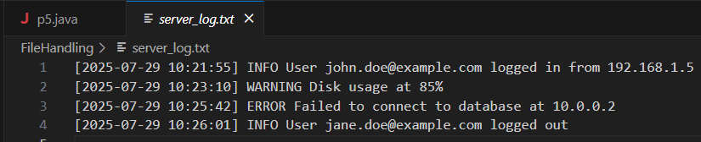

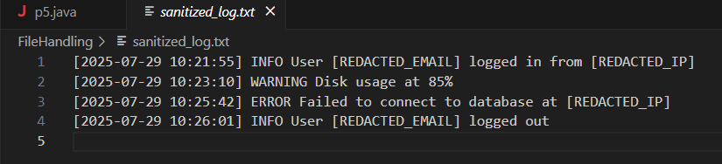

**Source Code-**

**Github :** [**https://github.com/RiGa7/Advanced-Java-Assginment**](https://github.com/RiGa7/Advanced-Java-Assginment)